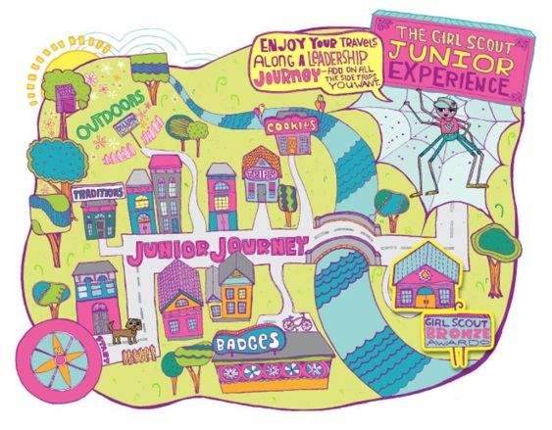
Troop Meeting
6 September 2013

Junior Program Leader(s): Stephanie, Laura, Julie
Troop Leaders On-site: Laura, Stephanie, Julie, Becky, Lainey
First Aider: Hajira

Girls Need to Bring: Monthly dues & their bags

 | Activity Description | Supplies/Assistance
6:30-6:45  All troop | - Check-in  - Make a First Aid Kit | - First aid kit supplies
6:45-6:50  Opening | Flag Ceremony | - Flag and stand
6:50-7:20  All troop | First Aid – Talk to First Responders - EMT visitors discussion  - What is an emergency?  - What do you do if you have an emergency? Call 911.  - What do you do if someone is choking?  - How do you treat minor injuries (cuts, scratches, bruises, insect bites)?  - What do you do if someone is having an allergic reaction or asthma attack? What do these look like?  - What do EMTs do?  - What equipment do you have in your ambulance and how does it work?  - What training do you have to have to be an EMT?
7:20-7:50  Juniors | 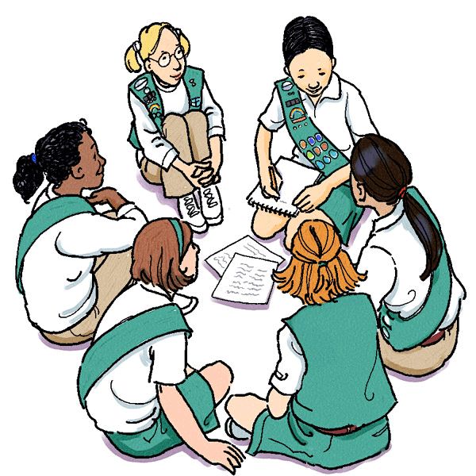  Junior First Aid  - #1 Learn the first steps to take in an emergency – Check, Call, Care
7:50-8:00  Closing | - Friendship squeeze | 